The Student Management Console Application

Date: <<09/10/2021>>

Copyright Notice

This document contains proprietary information of HCL Technologies Ltd. No part of this document may be reproduced, stored, copied, or transmitted in any form or by means of electronic, mechanical, photocopying or otherwise, without the express consent of HCL Technologies. This document is intended for internal circulation only and not meant for external distribution.

Revision History

| Version No | Date | Prepared by / Modified by | Significant Changes |
| --- | --- | --- | --- |
| 1.0 | 09/10/2021 | Hoai Vu |  |
|  |  |  |  |

**Table Of Contents**

1.1 Project Overview 3

1.2 Scope 3

1.3 Out of Scope 3

1.4 Intended Audience 3

1.5 High Level Use Cases 3

1.6 Use Cases detailed 3

1.7 User Interface Modules 3

1.8 Technical Architecture 3

1.9 Technical Detailed Description 3

1.10 Sequence Diagram 3

1.11 Database Entity Relationship Diagram 3

1.12 Standards 3

1.13 Non Functional Requirements 3

## Project Overview

A student management system (also known as a student information system or SIS) helps a school manage data, communications, and scheduling. A student management system helps schools to store, manage, and distribute this information. Some student management systems are designed to serve all a school’s student data management needs. Other student management systems are specialized. These specialized solutions target specific needs, such as school applications or student behavior tracking. Student management systems provide many benefits to educational institutions, mostly stemming from centralized data management and accessibility. Teachers can more easily input, manage, and access student data. Parental guardians get better visibility into how their student is performing in classes. State-level compliance and other regulatory requirements are also much easier to fulfill.

This project is created for manual testing at the end of term three in HLC, the first career program. It is a basic program used to manage student information based on the CRUD functions such as creating a new student, updating a student, displaying all students in a database, deleting a student, and searching for a student. This document has identified the high-level needs and features of the program.

## Scope

The Student Management System is basically focused on basic operations in local system so that its program does not have the user interface and we do not need to set up internet to implement the program. This program is specifically designed for practicing all knowledges we have learn during this course.

## Out of Scope

Not other than mentioned above in section 1.2

## Intended Audience

The Student Management System is designed for use of admins with student’s information

|  |  |  |
| --- | --- | --- |
| **Name** | **Description** | **Responsibilities** |
| Admin | The person manages student’s information | Create, update, search, view and delete student’s information |

## High Level Use Cases

## Use Cases detailed

## User Interface Modules

This system only has the local interface which is easy for user to use:

**1.7.1 List of options:**

**1.7.2 Add student:**

**1.7.3: Edit student:**

**1.7.4 Delete student:**

**1.7.5 Search function:**

**1.7.6 View function:**

**1.7.6. Quit function:**

## Technical Architecture

## Technical Detailed Description

|  |  |  |
| --- | --- | --- |
| Local System | Web Server | Database Server |
| 1. Interface of console program 2. Provide all user interaction 3. Communicate with Web Server to process the information | 1. Receive request from local system 2. Communicate with database server 3. Respond to local system 4. Applied business logic | 1. Manage data interaction 2. Respond to Web Server 3. Connect with SQL server 4. Contain all data of application |

## Sequence Diagram

**1.10.1 Add new student:**

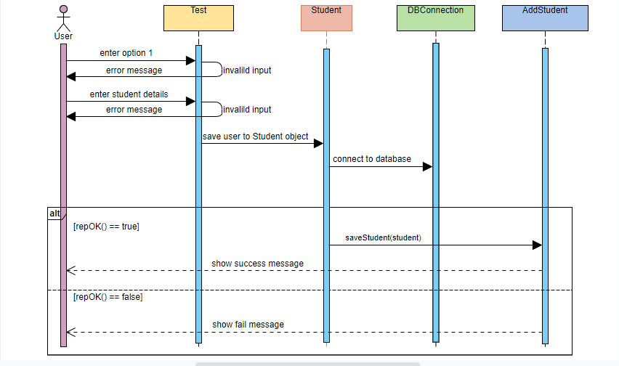

**1.10.2 Edit sutdent:**

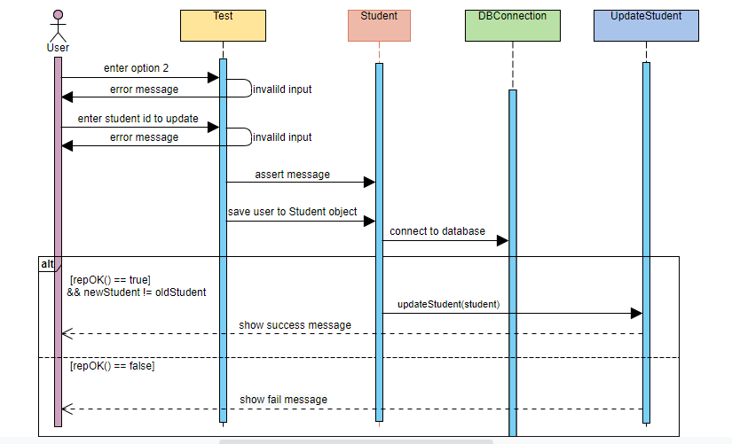

## 1.10.3 Delete student:

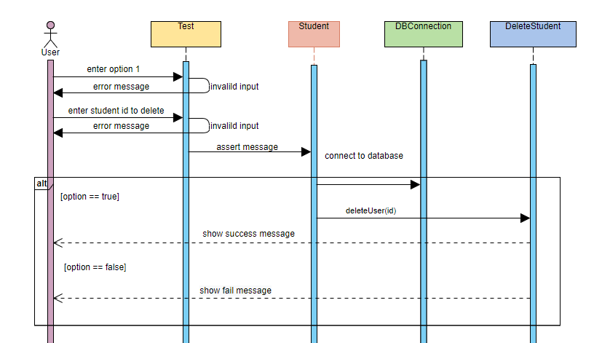

**1.10.4 Search student:**

**1.10.5 View student:**

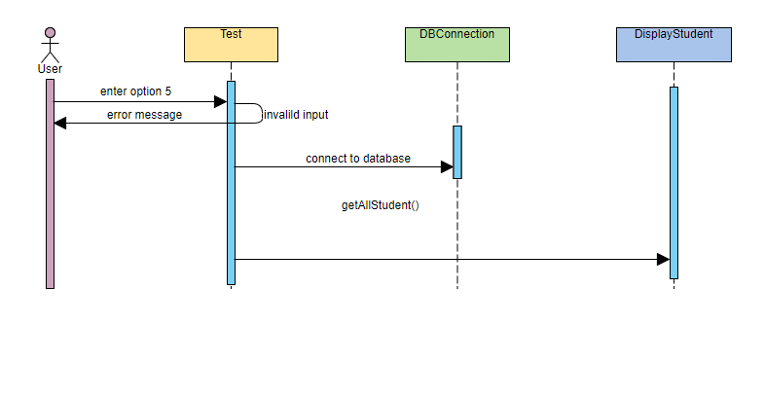

## Database Entity Relationship Diagram

## Standards

## Non-Functional Requirements

None